12.16: a) Using 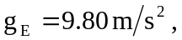Eq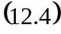 gives
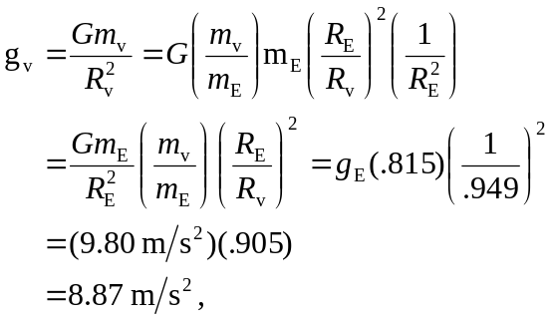
where the subscripts v refer to the quantities pertinent to Venus. b) 